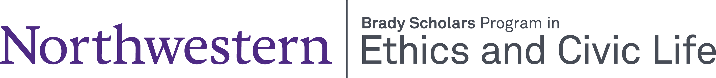

Application
Brady Graduate Fellowship
2026 – 2029

Name:

Contact Information:

Graduate Program or Cluster:

Undergraduate Institution and Degree:

What do you hope to learn from being in the Program? (500 words)

Briefly describe your next three years in school (research plans, travel, etc.)
(300 words)

Please request a recommendation from someone who knows you well. The letter should be sent to brady@northwestern.edu

Please submit your application and CV to brady@northwestern.edu by March 1, 2026.

If you do not receive an email confirming receipt of your application within three days, please contact k-arbuckle@northwestern.edu

