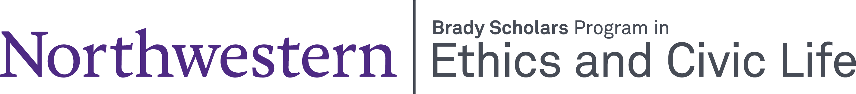
Brady Scholar Professor Reference Form for Class of 2028

Name:

Email Address:

I am recommending:

Please write a reference letter that describes why this student would be a good choice for the Brady Scholars Program.

Please return by April 7, 2025 via email to brady@northwestern.edu

